|  |
| --- |
| Functional Specification Document  <Good Food Mood> |

**DOCUMENT VERSION <V1>**

**<09.13.2021>**

**AUTHORS**

|  |  |  |
| --- | --- | --- |
| **Name** | **Role** | **Department** |
| Jan Emil Gustafsson | Business Analyst GooseFront AS | Digital Development |
| Jan Emil Gustafsson | Developer GooseFront AS | Frontend Development |

**DOCUMENT HISTORY**

|  |  |  |  |
| --- | --- | --- | --- |
| **Date** | **Version** | **Document Revision Description** | **Document Author** |
| 09-20-2021 | V1 | Draft Version | Jan Emil Gustafsson |
|  |  |  |  |
|  |  |  |  |
|  |  |  |  |
|  |  |  |  |

**APPROVALS**

|  |  |  |  |
| --- | --- | --- | --- |
| **Approval Date** | **Approved Version** | **Approver Role** | **Approver** |
| 09-13-2021 | V1 | Development Team Leader GooseFront AS | Jan Emil Gustafsson |
|  |  |  |  |
|  |  |  |  |
|  |  |  |  |

**Table of Contents**

1. Introduction 4

2. Purpose of the document 4

3. Risks and Assumptions 4

4. System/ Solution Overview 5

5. Functional Specifications 5

6. Mock-up 7

7. Integration Requirements 8

# **Introduction**

# Good Food Mood a new website which helps people find healthy and tasty recipes that are less time consuming. The site is aimed at working people who are interested in eating healthy and interesting food, but don’t have a lot of time to read recipe books. The site should be fun and engaging for users and guide them to take action. The site should take dietary concerns and ingredient choices into consideration when the user search for recipes and the resulting list of recipes. The site should also encourage users to sign up for a weekly newsletter with featured recipes.

# **Purpose of the document**

# The purpose of this document is to document the business requirements and functional rules of the Good Food Mood mobile app and website. This document will include a basic mockup of the website and on other platforms (tablet and smartphones).

# All system requirements and restraints will be documented.

# **Risks and Assumptions**

|  |  |  |  |
| --- | --- | --- | --- |
| **Risk** | **Level** | **Impact** | **Responsible** |
| User logins will not be saved for later use due to cookies not accepted. | High | Users logged in will be logged out after 4 hours of inactivity | Development Team |
|  |  |  |  |

# **System/ Solution Overview**

# **Functional Specifications**

### Develop an online site that is responsive on computer, tablet and smartphone.

### Purpose/ Description

Develop an online site that helps people find recipes for good food. Prompt users to sign up for a weekly newsletter with featured recipes.

### Continued on next page.

### Use case

|  |  |
| --- | --- |
| **UC-1** | **Let the users input ingredients and dietary concerns which produces a list of recipes.** |
| **Primary Actor(s)** | Users of webpage |
| **Stakeholders and Interest** | CEOBusiness Owner |
| **Trigger** | Create a website |
| **Pre-conditions** | Website does not exist |
| **Post-conditions** | URL of website to exist |
| **Main Success Scenario** | Enter one of Good Food Mood´s landing pages.Users input their ingredients and dietary concerns.A list of applicable recipes are displayed. |
| **Extensions** | If URL does not work, try google search for goodfoodmood.com |
| **Priority** | High |
| **Special Requirements** | A domain name and host to exist |
| **Open Questions** | <Notes and questions> |

|  |  |
| --- | --- |
| **UC-2** | **Create a sign-up page for the weekly newsletter:**  **Information about what the user gains from signing up for the weekly newsletter.** |
| **Primary Actor(s)** | Users of webpage |
| **Stakeholders and Interest** | CEOBusiness Owner |
| **Trigger** | Users looking for recipes that are aimed at people who are interested in food and are interested in eating healthy and interesting food and wants easy and fast access too new recipes. Give them the option to get a weekly newsletter with new and exiting recipes. |
| **Pre-conditions** | Page does not exist |
| **Post-conditions** | Sign up page up and running that sends users weekly newsletters. |
| **Main Success Scenario** | Enter Good Food Mood’s landing pages.  * 1. Click on the sign up sub-page.   2. Weekly newsletter example image.   3. Information about what signing up gives the user and information ensuring their information will only be used for sending weekly newsletters and not given to any other third party.  Enter user details in sign up form.Submit button and confirmation the sign up was successful. |
| **Extensions** | If sign up is not confirmed the form should highlight fields that need information or how the information should be typed in (@, .com, etc) |
| **Priority** | High |
| **Special Requirements** | Functional sign-up page and confirmation to the user the sign up was successful. |
| **Open Questions** | <Confirmation e-mail?> |

# **Mock-up**

Desktop and mobile:

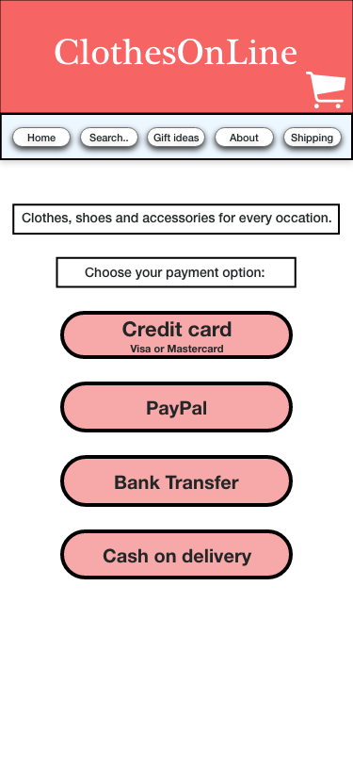

# **Integration Requirements**

